Ad ve Soyad:___________________________________________________ Sınıf:4/____ No:_____ ___/___/____ ENGLISH CLOTHES ,ACCESSORİES,JOBS,WEATHER AND MY FRİENDS 1)Aşağıdaki cümleleri sözcüklere göre tamamlayınız.
T-SHORT | SHORTS | SUNGLASSES | RAİNCOAT | UMBRELLA
HAT | SCARF | GLOVES
1)It’s sunny.Put on your ________________and___________________. 2)It’s sunny.Take your _________________________. 3)It’s rainy.Wear your__________________________. 4)It’s rainy.Take you __________________________. 5)It’s snowy.Put on your _______________________.
PUT ON=GİY | WEAR =GİY | TAKE =AL
2)Aşağıdakileri resimlerin altına İngilizcelerini yazınız.
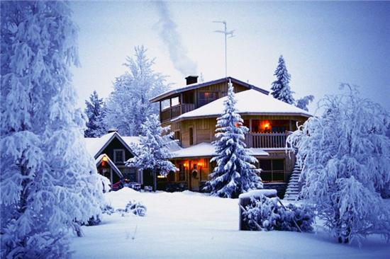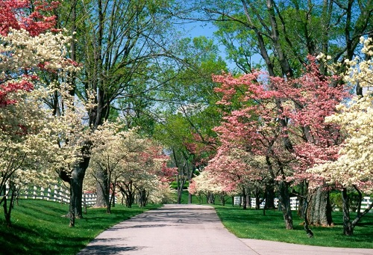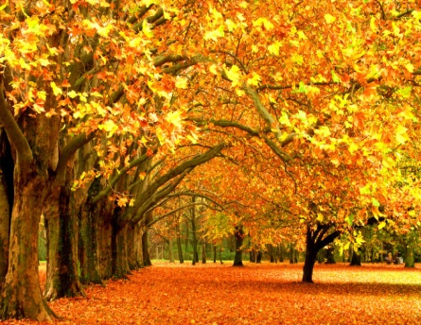
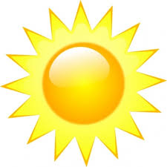
3)Aşağıdaki soruları cevaplayınız. 1)What’s the weather like in spring? ________________________________________________________________________________________2)What’s the weather like summer? ________________________________________________________________________________________ 3)What’s the weather like in autumn? ________________________________________________________________________________________4)What’s the weather like in winter? ________________________________________________________________________________________ 5)What’s the weather like in warm? ________________________________________________________________________________________
4)Aşağıdaki resimlere göre soruları yanlarına cevaplayınız.
1)What do you do?_______________________________________________________________
2)Where do you work?______________________________________________________________
1)What do you do?_______________________________________________________________
2)Where do you work?______________________________________________________________
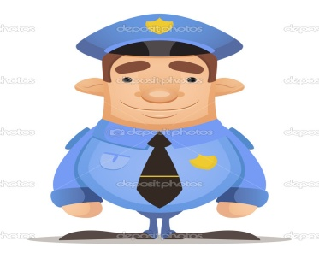
1)What do you do?_______________________________________________________________
2)Where do you work?______________________________________________________________
5)Aşağıdaki soruları yanındaki resme göre yapınız.
1)What does he look like? /What is he like ?
2) What does he look like? /What is he like ?
3)What does she look like? /What is she like ?
4) What does she look like? /What is she like ?
1) 2)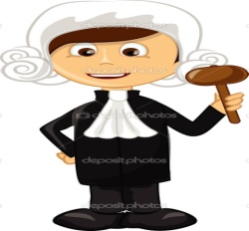 3)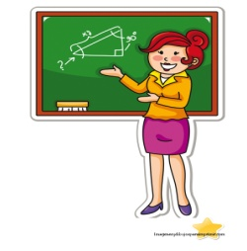 4) 6)Aşağıdaki kelimelerin Türkçelerini altlarına yazınız.
UZUN /QUİT | FAT/HELPFUL | WAWY HAİR | STRA İGHT HAİR | FAİR HAİR | DARK HAİR
/ | /
SMAL NOSE | BİG MOUTH | BALD | BEARD | MOUSTARHE | BLUE EYES
SHY/Hardworking | LAZY/Energetic | KİND /NİCE | CHERRFUL/Rude | UGLY/Funny | BEATİUFUL
/ | / | / | / | /

